Task list of DMS

1. Duplicate should be check for all team and department (done)
2. All validation should be JQuery or React (done)
3. Numeric should be check on all forms and fields(Done)
4. First letter of Name should be as capital letter and also insteam of username it should be as First Name and Last name as per below form and it should be global as well. (done)

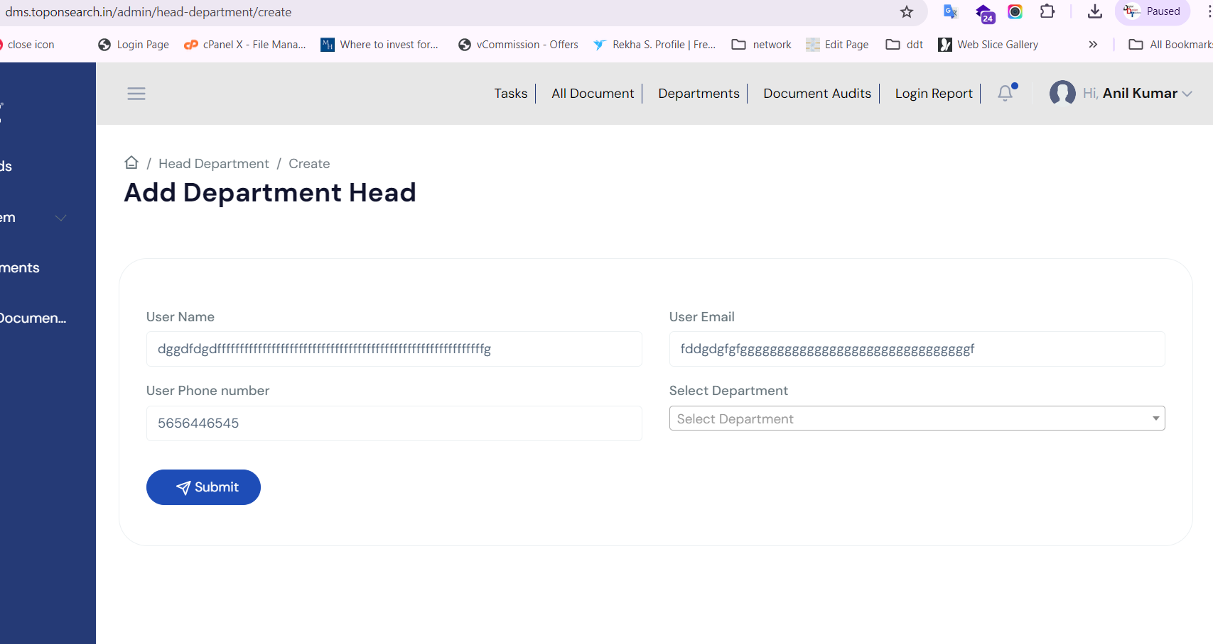

1. While creating Unit Phone no and email with department head option is not required in user it should be as First name and last name. (done)
2. 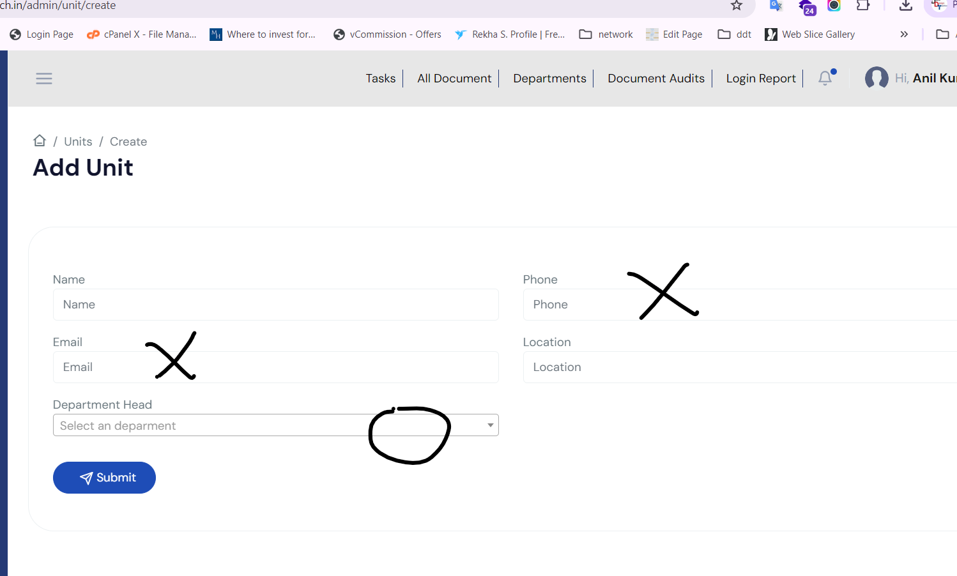
3. In list report data will display order by name only--------
4. For user creation it should simple like designation, department , Unite (it will count as Gurgaon office) and reporting Manager (done) testing pending
5. In login page remember me and password change should be work and we don’t required Signup page so please remove the link (done)
6. 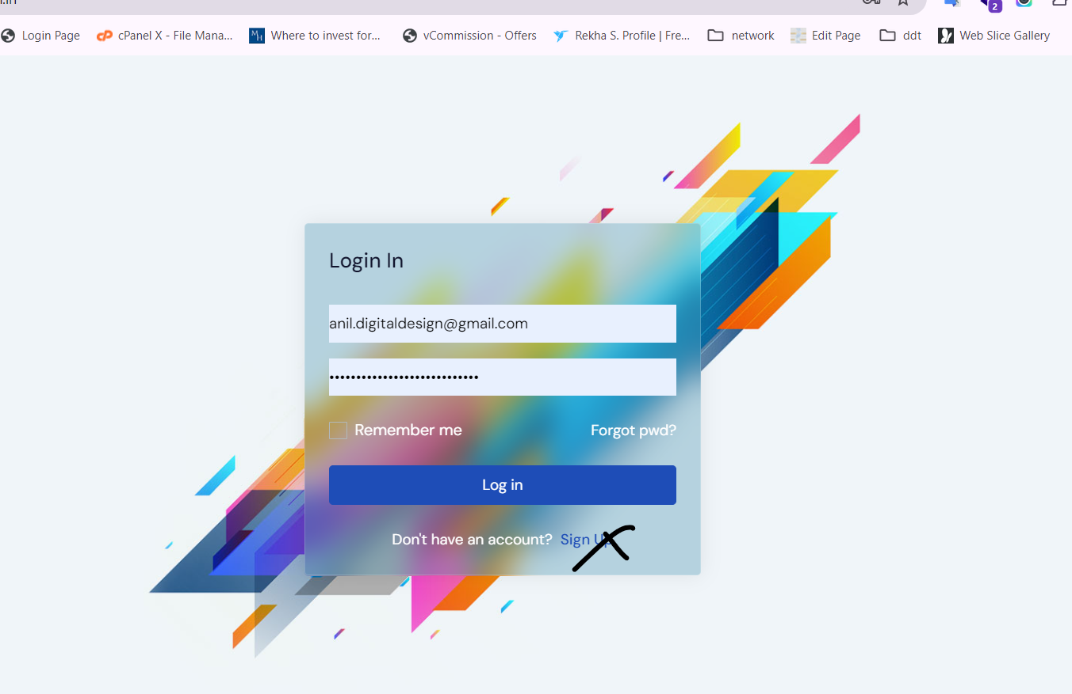
7. In dashboard if document is not shared as recent then message will popup as “No Recent data available” (done)
8. While creating any new folder the name of folder will not be more that 30 words(done)
9. While login on application if password is not correct then message should be display as Wrong password(done)
10. 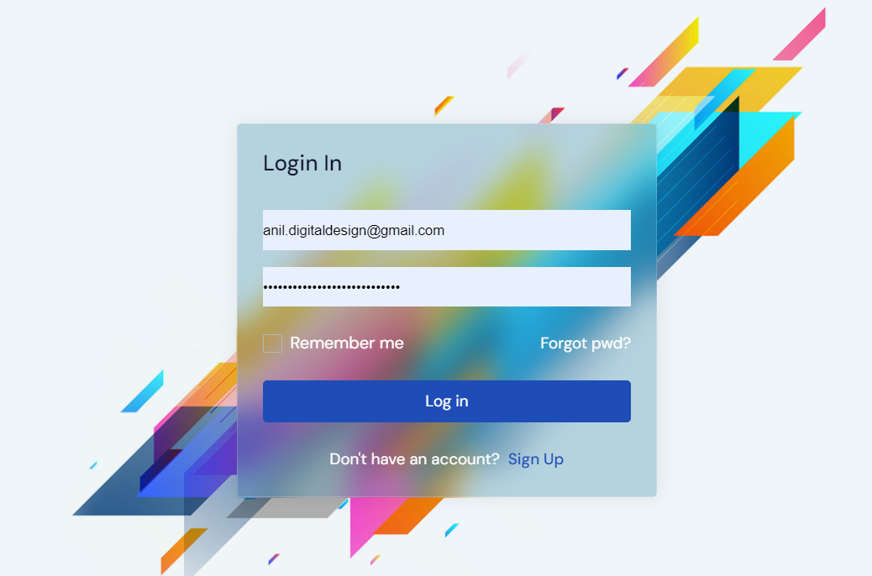
11. Passw ord should be generate automatically for all modules (done)
12. Active and inactive functionality should be in all modules.(Done)
13. List of Active and inactive hotels, users, department should be visible in Admin panel only.
14. After creation of users or giving any access on document or folder email alerts will goes to users as well(Done)
15. Once the permission will be provide on documents and folder the popup message will come on that screen.(Done)
16. Pie chart should be display as per department it is already working but we need to test thoroughly.
17. In users edit email id should be non-editable.(done)
18. Need to design a error page(Done).
19. dms_1.png - You can see, I have been able to add users with special characters in name fields. While adding a user, I was able to add 2 people as Deaprtment***Head***in ***same unit*** and ***same department.***I hadchosen ***BL Park***as Unit and ***Jaipur***as the location, and ***Administration*** as the department.(Done)
20. 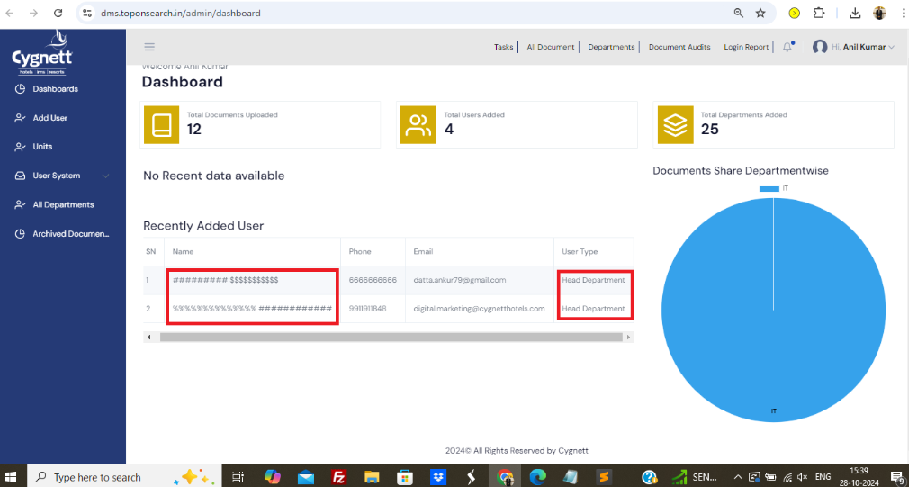
21. dms_2.png - ***Multiple insatances*** of same unit name in same location. Secondly, location should be a ***master*** as well.(Done)
22. 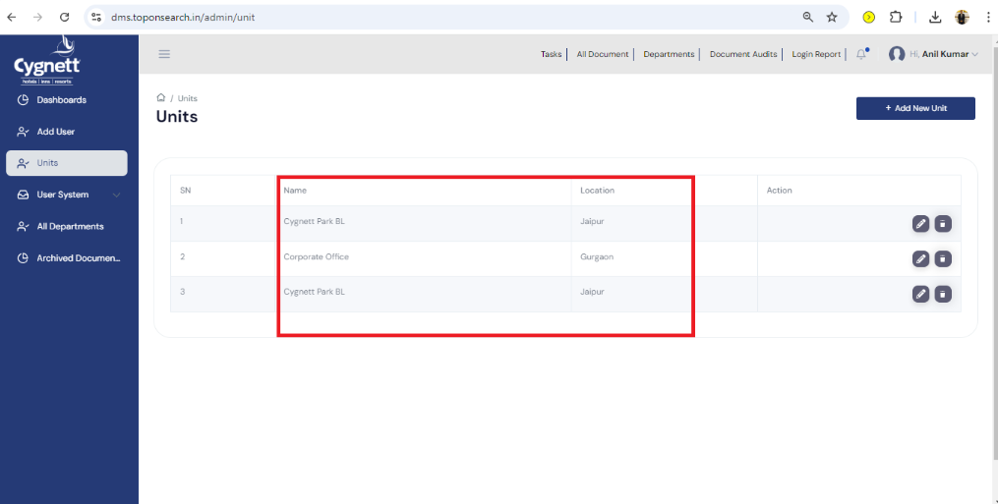
23. dms_3.png - ***Multiple documents*** with same title.Moreover, the system is allowing to upload any type of files. I have been able to upload php and js files. A DMS should only allow documents like doc/xls/pdf/ppt/txt. [@Sachin Gaur](mailto:sachin.gaur@cygnetthotels.com) , [@Hem chandra](mailto:hem.chandra@cygnetthotels.com) , [@Sugata De](mailto:sugata.de@cygnetthotels.com)  - please share your thoughts on this.(Done)
24. 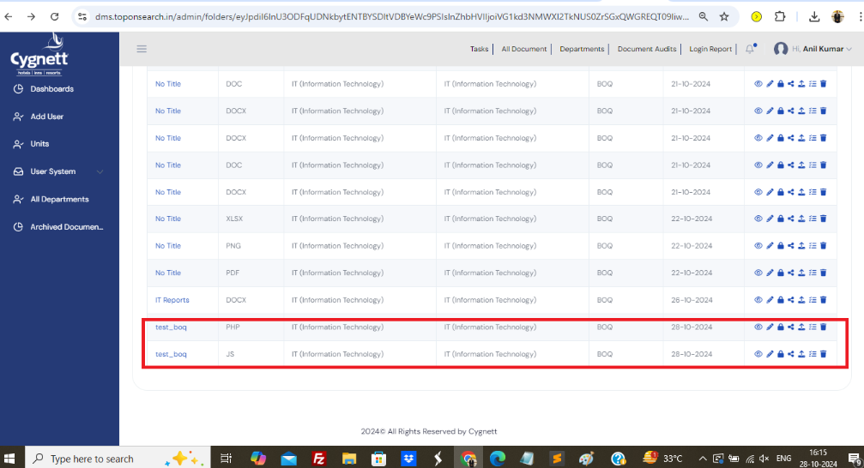
25. dms_4.png - Similar named department can be added multiple times.(Done)
26. 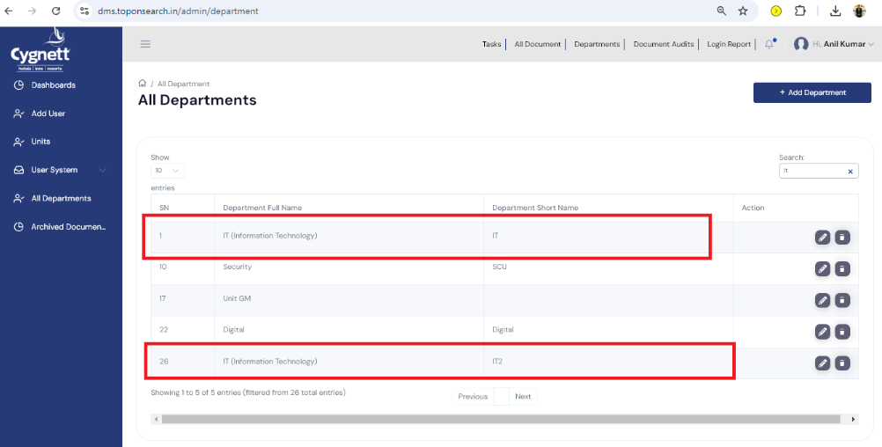
27. From my observations, pagination typically has been implemented using the data-table feature. While this method is effective for smaller datasets, our data is expected to grow significantly. Therefore, to ensure robust and flexible searches, we need to implement custom server-side pagination(Done)
28. Listing of data should be in descending order(Done)